15.7: a)
b) 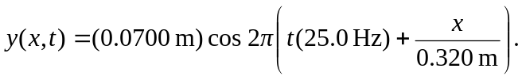
c)
d) The argument in the square brackets in the expression used in part (c) is 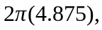 and the displacement will next be zero when the argument is 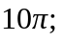 the time is then and the elapsed time is 